City of Omak: Parks and Recreation Plans
We currently have open positions on our Parks Board, and participants are required to live within Omak city limits. If you're interested in serving, please submit a letter of interest to admin@omakcity.com or drop it off at Omak City Hall (2 N. Ash St., Omak).
Vision: Omak’s parks provide attractive open spaces and facilities for sports, wellness, and connection with nature, distributed throughout the community for residents and visitors, providing a focus on the river, and encouraging walking and bicycling. The City of Omak will foster community involvement and partnerships that support the operation, improvement, and utilization of its parks.
Goals and Objectives
Omak has long recognized that parks and recreation make a substantial contribution to the “quality of life” for Omak area residents. At the same time, resources available to support recreation are limited, so the City must prioritize among many possible alternatives and desires. Well-defined parks and recreation goals and objectives are intended to guide the City’s decisions in addressing residents’ most important recreational needs.
Goals are broad statements of intent or ambition. Objectives provide more specific measurable targets to aid in achieving goals.
Goal 1: Provide recreational opportunities for all ages and for the diverse population of the community and its visitors.
Objectives:
- Recruit Park Board membership representing the age and cultural diversity of the Planning Area.
- Strengthen involvement, coordination, and support from the Tribes and tribal membership, particularly regarding the Eastside Park.
- Assess and balance the provision of facilities that invite participation from the full range of ages and abilities.
Goal 2: Maintain and improve parks facilities to provide positive recreational experiences for residents and visitors.
Objectives:
- Maintain park facilities and open space in excellent condition.
- Upgrade or replace facilities at end of service life or when appropriate, to improve public benefits or reduce maintenance and operational costs.
- Carry out an assessment of the swimming pool condition to develop a plan and schedule for its replacement.
Goal 3: Encourage involvement by residents and partnerships with other organization in the development and management of parks.
Objectives:
- Coordinate with the Tribes, Omak School District, other public agencies, and other entities in planning for parks and recreational facilities.
- Encourage and foster partnerships to maintain and improve Omak’s neighborhood parks.
- Recruit and support an active, ambitious Park Board to assist in public outreach and advise the City regarding implementation of this plan.
Goal 4: Balance provision of facilities for organized sports and events with neighborhood parks and trails.
Objectives:
- Improve linkage between parks with pedestrian and bicycle-friendly pathways.
- Install signage or other identifying markers for each park and open space, welcoming use appropriate to each park’s setting.
- Continue redevelopment of the Eastside Park, guided by its master plan and continued evaluation of community and Tribes recreational needs.
Goal 5: Increase water access to and enjoyment of the Okanogan River.
Objectives:
- Provide/improve trails that utilize the River Overlook and Aston Island open space areas.
- Increase the length of flood control levee accessible to public trail use.
- Develop additional access points to the Okanogan River that balance human use with ecosystem function.
Goal 6: Broaden and increase sources of funding for recreational features and programs.
Objectives:
- Encourage and honor contributions by volunteers, local organizations, businesses, and Tribes.
- Search for and connect with grant agencies and foundations with goals matching the City’s recreational goals and objectives
- Evaluate formation of a parks and recreation district to build additional capacity supporting recreation within the Planning Area.
City of Omak
Park and Open Space Inventory
Park/Open Space Name | Acreage | Primary Purpose
Aston Island open space | 19.00 | River front; forested floodplain, wildlife and nature observation, informal trail.
Civic League Park | 1.50 | At City center; lawn, band shell, playground equipment, restroom facilities, picnic tables, events
Dalton-Klessig Park | 1.00 | Neighborhood park; lawn, walking trail, memorial trees/benches, rest area, play equipment.
Eastside Park | 76.60 | Destination park; 8,000 seat rodeo arena, swimming pool, baseball and soccer fields, Native American dance pavilion, camping with RV hookups, exercise and river levee trails, basketball courts, picnic area, skate park, visitors center and Stampede museum, veteran memorial
Ivy Park | .25 | Green space; lawn
Johnny’s Park | .25 | Green space; lawn
Julia Maley Park | .15 | Neighborhood park with playground equipment
Kiwanis Park | .25 | Neighborhood park; children’s ball field and basketball court
Koala Parcel | .35 | Open space reserved for future park development
Law Enforcement Memorial | .15 | Green space/stormwater retention area; hardscaped, law enforcement memorial
Maley Park | .50 | Green space; lawn, shade trees
Oak Street Park | 3.00 | Neighborhood park; ball fields and concession stand
Okanogan River |  | Water of Statewide Significance; 2.7 miles of river lie within or bound city limits.
Omak Pioneer Park | 1.00 | Neighborhood park on river levee; river overlook with benches and gazebo
Patterson Park | .25 | Green space; lawn, bench
River Overlook open space | 28 | Covered landfill with shrub steppe vegetation; river front (overlook only at this time), walking trail
Suicide Race Hill | .58 | Open space, site of start and hill for World Famous Suicide Race

City of Omak Parks Locations
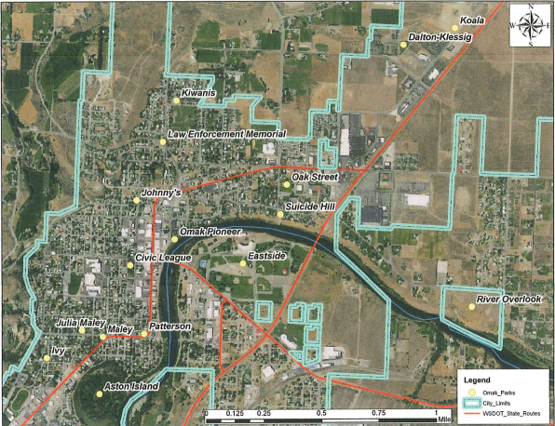
Agenda for Planning Meeting #1
1. Welcome & Introductions
- Sign-in with name and email.
- Todd McDaniel (City Administrator) will preface the meeting with the City’s role in maintaining the parks and recreational spaces.
2. Review Purpose of Meeting
- Focus: Improving the City of Omak’s parks and recreational spaces
- Goal: Identify specific concerns, barriers, and ideas for improving the parks and recreational spaces in our city.
3. Round Robin Discussions (Approx. 30 minutes)
- Topic 1: Current Concerns about City Parks and Recreational Activities
  - Baseball/Little League Fields
  - Soccer Fields
  - Parks
    - Civic League Park, Dalton-Klessig Park, Eastside Park, Ivy Park, Johnny’s Park, Julia Maley Park, Kiwanis Park, Maley Park, Oak Street Park, Omak Pioneer Park, Patterson Park
  - Recreational Spaces
    - Example: Horseshoe pits, tennis courts, pickleball courts, skatepark, walking path, basketball courts, swimming pool
  - Other
- Topic 2: Park and Recreation Space
  - Baseball/Little League Fields
  - Soccer Fields
  - Parks
  - Recreational Spaces
  - Other
- Topic 3: Ideas for Improving the Park and Recreational Space
  - Baseball/Little League Fields
  - Soccer Fields
  - Parks
  - Recreational Spaces
  - Other
4. Wrap-Up & Next Steps
- Discuss data compilation: Responses will be gathered, compiled into a spreadsheet, and shared via email and on the city website prior to Meeting #2.
- At the next meeting (Meeting #2), review data to identify common themes, trends, and priorities.
- Discuss action steps for the next phase.
Agenda for Planning Meeting #2
1. Welcome & Recap of Meeting #1
- Brief recap of the purpose of Meeting #1 and the data collected.
- Overview of the compiled data from Meeting #1 (displayed on large screen).
2. Group Breakouts
- Participants select a group based on their focus area: Baseball Fields, Soccer Fields, Parks, Recreational Spaces, or Other.
  - Participants are welcome to move around to different groups during this time.
- Each group will review the data and discuss the following:
  - Top 3 Priority Areas
  - Ideas for Addressing Priority Areas
  - Action Steps Needed to Address Each Priority Area
    - Who is assigned to each action step? (Ensure that only those present are assigned tasks.)
3. Group Presentations
- Each group presents their top priorities and proposed action steps to the full group.
4. Wrap-Up & Next Steps
- Recap action steps and assignments.
  - All identified priority areas will be compiled in a list and submitted to the Parks Committee for review.

